41st Palo Alto Summer Bird Count – 5 June 2021
The count circle has a diameter of 15 miles, with center at 37° 24′ N 122° 09′ W near the intersection of Junipero Serra Blvd and Page Mill Rd. The territory covered is the same as for the Audubon Christmas Bird Counts.
The 97 participants on the count were in the field between 5:35 am and 8:30 pm on June 5th. No parties reported owling or feeder watches. The breakdown of time in the field showed 57 parties spent 234.9 hours counting on foot, covering 274.0 miles. Eight parties spent 21.4 hours by bicycle, covering 61.8 miles, and nine parties spent 8.1 hours by car, covering 51.8 miles. Weather during the day was clear to partly cloudy with a light breeze in the afternoon, temps from 48 – 80 F, and fog in the morning in the hills.
Canada Goose 1051, Wood Duck 1, Blue-winged Teal 4, Cinnamon Teal 5, Northern Shoveler 18, Gadwall 165, American Wigeon 5, Mallard 1349, Northern Pintail 1, Green-winged Teal 8, Canvasback 7, Redhead 5, Lesser Scaup 9, Surf Scoter CW, Common Goldeneye 3, Ruddy Duck 172, duck spp. 33, California Quail 136, Wild Turkey 92, Pied-billed Grebe 33, Eared Grebe 1, Western Grebe 3, Clark's Grebe 42, Aechmophorus spp. 58, Rock Pigeon 178, Band-tailed Pigeon 172, Eurasian Collared-Dove 37, Mourning Dove 346, Vaux's Swift 5, White-throated Swift 48, Anna's Hummingbird 365, Allen's Hummingbird 13, Ridgway's Rail 3, Common Gallinule 7, American Coot 42, Black-necked Stilt 117, American Avocet 237, Black Oystercatcher 1, Black-bellied Plover 14, Killdeer 37, Snowy Plover 13, Whimbrel 2, Long-billed Curlew 10, Marbled Godwit 872, Ruddy Turnstone 4, Western Sandpiper 10, Long-Billed Dowitcher 2, Willet 194, Greater Yellowlegs 170, Ring-billed Gull 11, Western Gull 3, California Gull 6564, gull spp. 151, Caspian Tern 247, Common Tern CW, Forster's Tern 791, Black Skimmer 100, Double-crested Cormorant 350, American White Pelican 165, Brown Pelican 12, Great Blue Heron 21, Great Egret 71, Snowy Egret 127, Green Heron 6, Black-crowned Night-Heron 23, Turkey Vulture 153, White-tailed Kite 21, Northern Harrier 2, Cooper's Hawk 20, Accipiter spp. 2, Bald Eagle 3, Red-shouldered Hawk 43, Red-tailed Hawk 92, Barn Owl 1, Western Screech-Owl 1, Great Horned Owl 5, Burrowing Owl 1, Belted Kingfisher 3, Acorn Woodpecker 285, Downy Woodpecker 16, Nuttall's Woodpecker 139, Hairy Woodpecker 52, Northern Flicker 29, Pileated Woodpecker 7, woodpecker spp. 1, American Kestrel 11, Peregrine Falcon 6, Ash-throated Flycatcher 68, Western Kingbird 5, Olive-sided Flycatcher 10, Western Wood-Pewee 10, Pacific-slope Flycatcher 67, Black Phoebe 212, Say's Phoebe 2, Hutton's Vireo 67, Cassin's Vireo 3, Warbling Vireo 73, Steller's Jay 248, California Scrub-Jay 295, American Crow 583, Common Raven 182, Tree Swallow 45, Violet-green Swallow 288, Northern Rough-winged Swallow 56, Barn Swallow 332, Cliff Swallow 587, swallow spp. 29, Chestnut-backed Chickadee 1042, Oak Titmouse 416, Bushtit 418, Red-breasted Nuthatch 3, White-breasted Nuthatch 219, Pygmy Nuthatch 34, Brown Creeper 51, House Wren 41, Pacific Wren 11, Marsh Wren 57, Bewick's Wren 253, Blue-gray Gnatcatcher 45, Wrentit 160, Western Bluebird 250, Swainson's Thrush 24, Hermit Thrush 1, American Robin 205, California Thrasher 15, Northern Mockingbird 111, European Starling 218, Cedar Waxwing 5, House Sparrow 73, House Finch 1234, Purple Finch 78, Pine Siskin 13, Lesser Goldfinch 762, Lawrence's Goldfinch 2, Grasshopper Sparrow 26, Chipping Sparrow 4, Dark-eyed Junco 1077, Golden-crowned Sparrow 1, Savannah Sparrow 41, Song Sparrow 280, California Towhee 297, Spotted Towhee 520, Western Meadowlark 13, Hooded Oriole 19, Bullock's Oriole 23, Red-winged Blackbird 197, Brown-headed Cowbird 67, Brewer's Blackbird 20, Great-tailed Grackle 2, Orange-crowned Warbler 101, MacGillivray's Warbler 10, Common Yellowthroat 46, Black-throated Gray Warbler 10, Hermit Warbler 4, Wilson's Warbler 107, Western Tanager 4, Black-headed Grosbeak 35, and Lazuli Bunting 33.
[Species listed in boldface have occurred on seven or fewer prior counts. Numbers in red boldface are record high counts. Numbers in red italics are record low counts. Species listed in blue were confirmed breeding. Species found during count week but not on count day are shown as “CW.”]
Total: 150 species and 27,475 individuals.
Participants: Dwight Agan, John Allan, Mary Ann Allan, Dorian Anderson, Aparna Sherlekar Banerjee, Bill Bauriedel, Marilyn Bauriedel, Leonie Batkin, Curt Bianchi, Dan Bloch, William G. Bousman, Cathy Brown, Doug Brown, Juliette Bryson, Adam Burnett, Will Buxton, Agnes Caulfield, John Caulfield, Barbara Coll, Ellen Corey, Sue Cossins, Charles Coston, Ana Davidson, Malia DeFelice, Kelly Dodder, Matthew Dodder, Hazel Donaldson, Pete Dunten (compiler), Ed Ehmke, John Epperson, Rich Ferrick, Leslie Flint, Kent Forward, Harold Fukuma, Davena Gentry, Alex Gilbert, Deanna Gomby, Garth Harwood, Peter Headland, Ann Hepenstal, Howard Higley, David Hohmann, Kirsten Holmquist, Winnifred Homer-Smith, Susie Hons, Richard Jeffers, Ben Johnson, Linda Sue Johnson, Matisse Kallman, Dan Keller, Don Keller, Emily Kim, Peter Kim, Marion Krause, Jim Liskovec, Sue Liskovec, Joan Loney, Chris MacIntosh, Michael Mammoser, Ginny Marshall, Carol Mathews, Sonny Mencher, Valerie Neer, Christin New, Rich Page, Mary Jane Parrine, Devin Peyton, Troy Pittock, Donna Pomeroy, Michael Rogers, Pati Rouzer, Jennifer Rycenga, Amy Sanchez, Mike Sanchez, Lisa Schechter, John Sebes, Emma Shelton, Mike Shur, Martin Sidor, Clare Smith, Cliff Smith, Scott Smithson, Kathryn Strachota, Susan Stratton, Jane Tatchell, Jack Tomlin, Kitty Trejo, Alia Tu, Luis Villablanca, Bill Walker, Zihan Wei, Jim Weigand, Marcia White, Christopher Wilson, Mary Wisnewski, David Zittin, Floy Zittin
Commentary:
The count surpassed all previous counts with the highest number of parties in the field (61) and the number of participants (97). Another measure of effort, party-hours, was the second highest ever. Contrary to these rosy trends, the average number of hours spent by each party was an all-time low, at 4.3 hrs/party. Counters were not able to access levees along San Francisco Bay, some areas in the Santa Cruz Mountains and Moffett Field, either in 2021 or in 2020, one of the continuing effects of the Covid-19 pandemic.
The number of species recorded, 150, was slightly above the average of 147. The summer of 2021 saw extreme drought conditions, with below normal precipitation for a second year in a row. Despite this, the number of birds found per party hour was only one standard deviation below the long-term average.
One species was new to the count, a Golden-crowned Sparrow. The sparrow had an injured wing but was otherwise healthy and singing. The Golden-crowned joins 28 other species only recorded once, a group that includes wintering birds late to migrate (perhaps due to injury), some late migrants, late spring Eastern vagrants, and a few others. One hybrid was also new to the count, a presumed Downy x Nuttall’s Woodpecker that has been present along Stevens Creek and nearby Charleston Rd Marsh since April of 2020. There was also a near miss for an addition to the count. The second-year Common Tern that spent the summer at Emily Renzel Wetlands and a few other bayside locations was found during count-week.
Ring-necked Pheasant and American Goldfinch were both missed for the third time in the last five years. On the bright side, Western Wood-Pewee numbers rebounded from a low of 2 in 2020 to 10 in 2021. The trend line for the population in the count circle is still downwards, with numbers decreasing by about 5% per year. Blue-winged Teal returned after an absence of 10 years, with a count of 4 at one of the Lockheed ponds in Sunnyvale. Ruddy Turnstone, missed the last 9 years, were also found in 2021. Turnstones in June would be birds that did not migrate north to breed. They’ve been noted on the count in 4 years.
Some cavity nesters are doing well, while others are in decline. In the first category are Hairy Woodpecker and White-breasted Nuthatch, both found in record numbers. The count of Hairy Woodpeckers, 52, surpassed the previous high count of 48 and was well above the average of 18 (expressed as 52 vs 18/48). In those terms, the White-breasted Nuthatch count was also exceptional (219 vs 70/162). The long-term trend for Hairy Woodpecker is a 3.0% increase in population per year. While Hairy Woodpeckers don’t make use of nest boxes, White-breasted Nuthatches may do so. For comparison, Western Bluebirds have increased by 5.1% per year, thanks in large part to a long effort to provide nest boxes in suitable habitat. Other cavity nesters are not doing so well. Downy Woodpecker counts are decreasing by 3.2% per year.
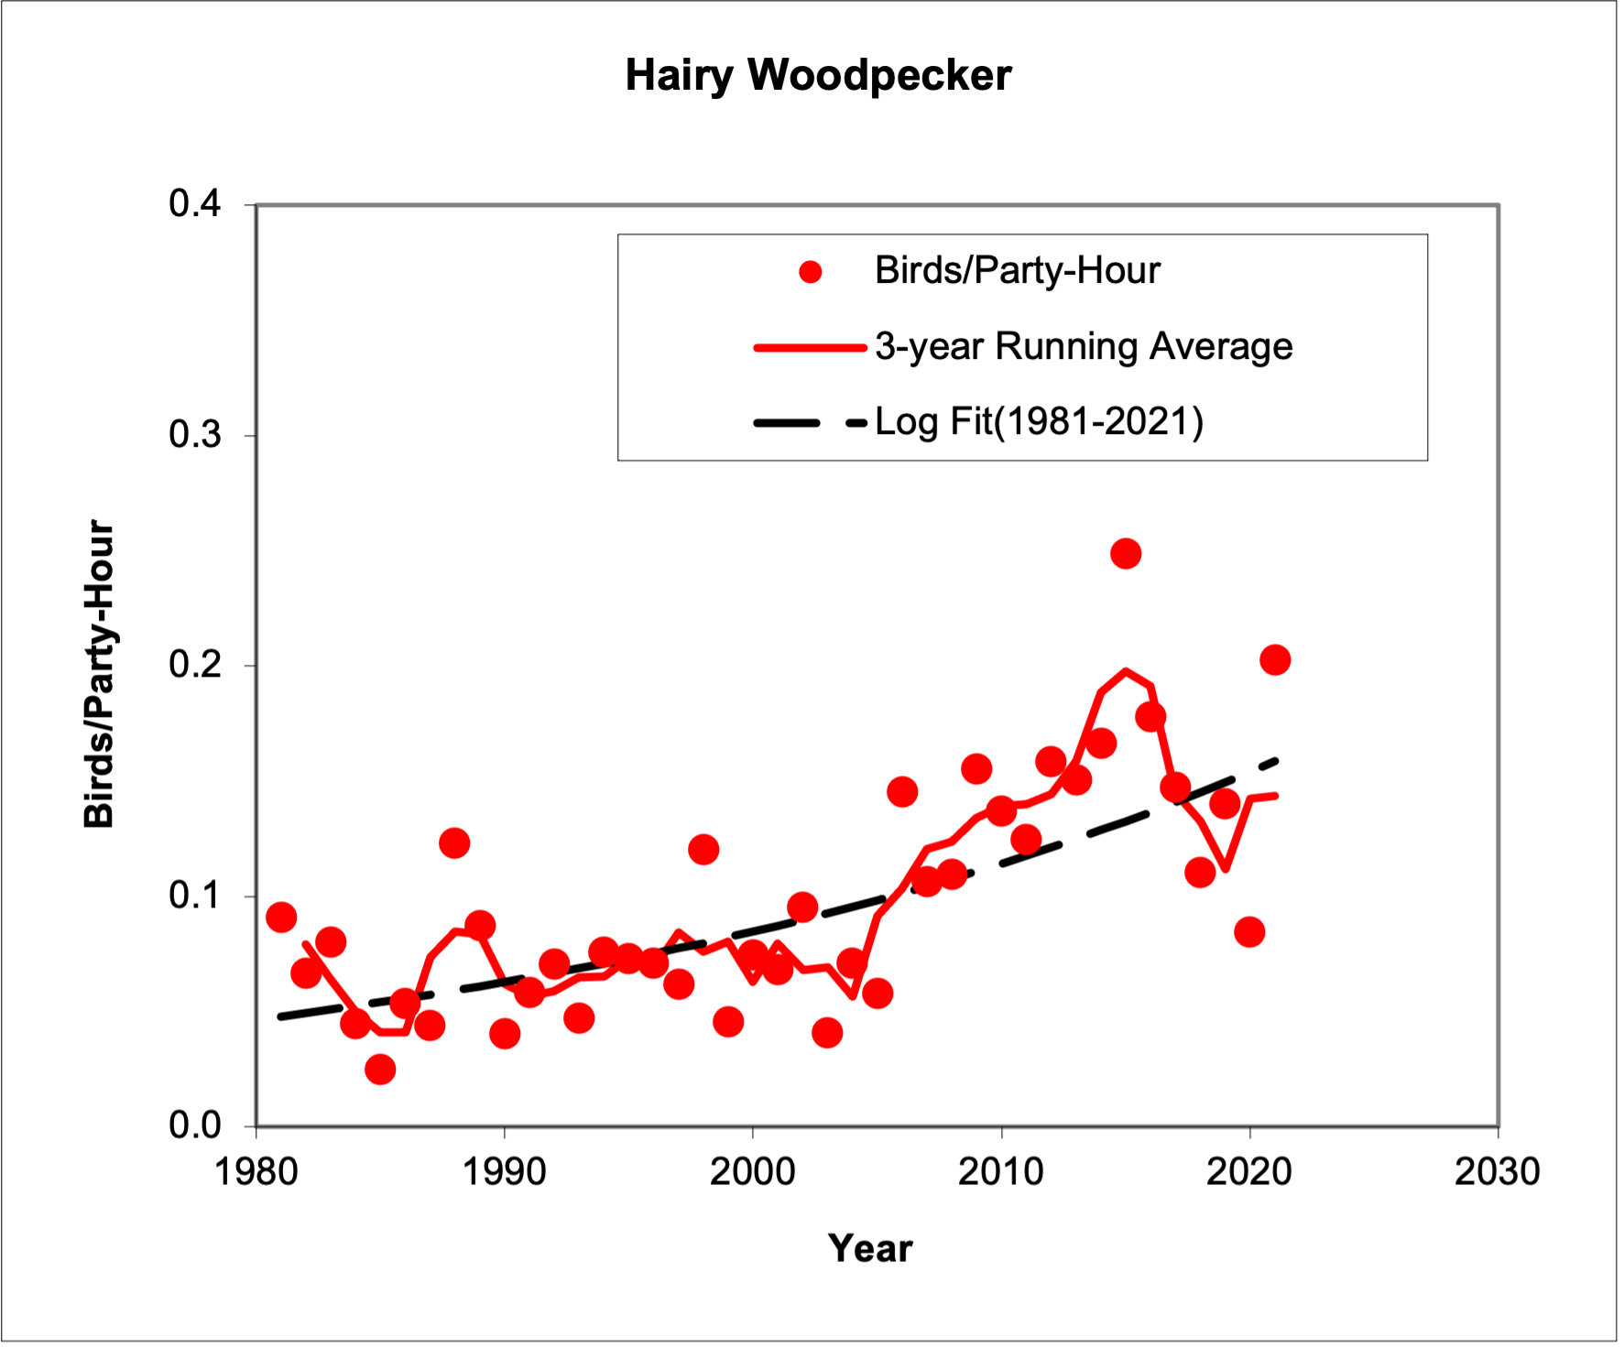
One increasing cavity nester, Hairy Woodpecker
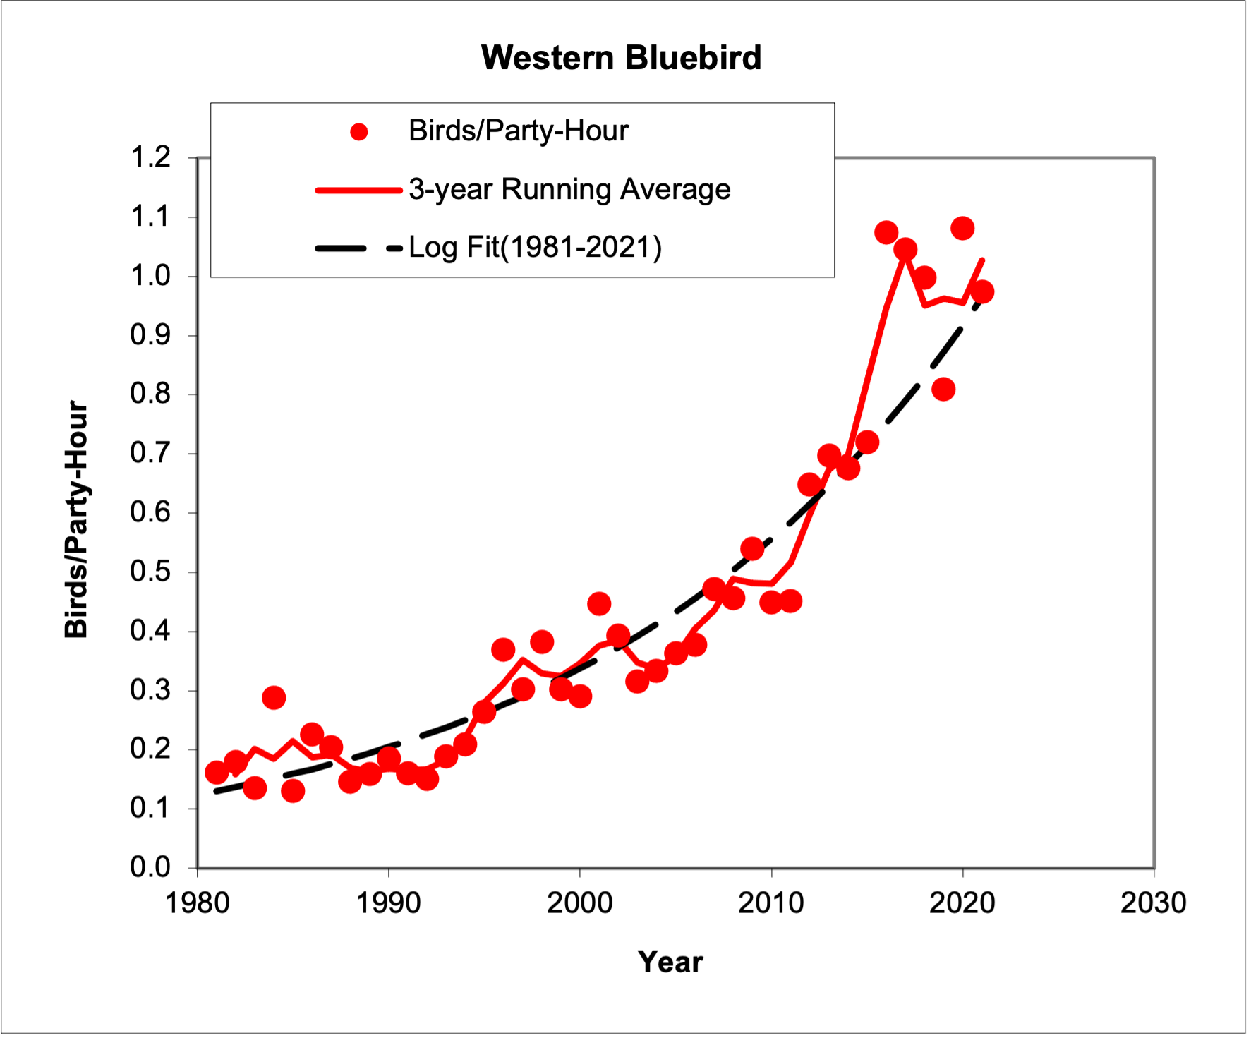
Western Bluebirds are also doing well

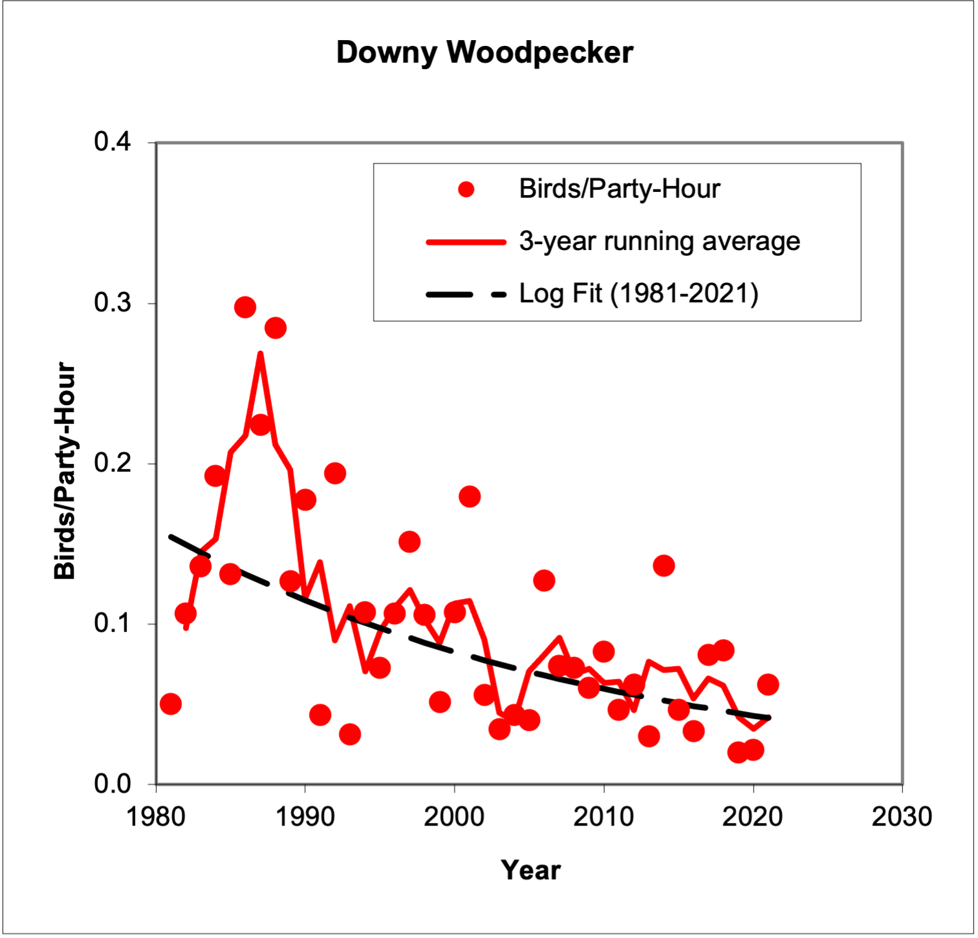
A cavity nester not fairing as well, Downy Woodpecker
For species found in low numbers it is difficult to know if apparent trends are real or merely random sampling errors. Cases in point would be species such as MacGillivray’s Warbler and Western Kingbird. The mean count for Western Kingbird for the years 1981 – 2010 was 1. In 2011 rain during count day grounded migrants and 12 Kingbirds were tallied along the bay. The mean count for the years spanning 2012 – 2021 was 6. So even discounting the anomalous count in 2011, the apparent trend for Western Kingbird is positive, indicating a range expansion. The last two years they’ve been found in the western part of the count circle on Stanford land in Santa Clara County and at La Honda Creek OSP in San Mateo County. MacGillivray’s Warbler has also been found in low numbers over the years, with high counts of 14 in 2020 and 10 in 2021. Most of those birds were noted at one location, Windy Hill OSP in San Mateo County. Given the warbler has been present in that part of the count circle over the years, and the warbler’s preference for sulking in low, dense vegetation, it seems prudent to conclude the recent high counts are likely due to sampling variation.
Bald Eagles nested again at Felt Lake this year. Two fledged young and one adult were present. Bald Eagle first occurred on the count in 2015. Since 2019 they’ve succeeded every year in fledging young at Felt Lake.
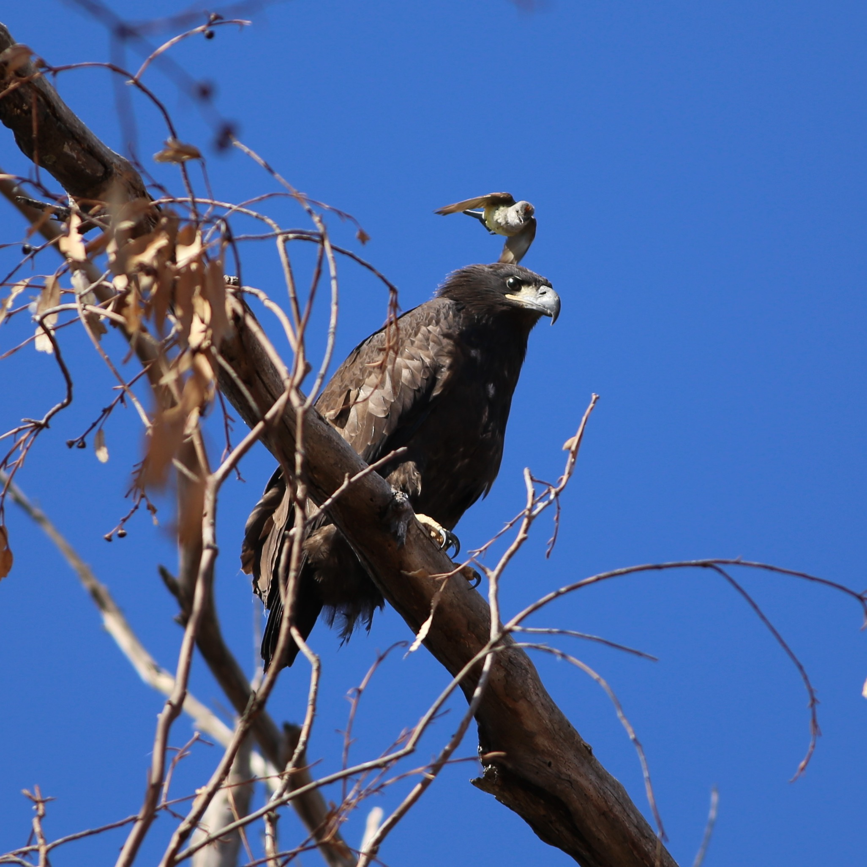
Adult Western Kingbird harasses a young Bald Eagle at Felt Lake
Black Skimmer is another species with recent success nesting in the count circle, with the colony at Shoreline Lake responsible for the increase in numbers. The Skimmer colony at Shoreline Lake more than doubled the previous high count, to 100 birds this year. Black Oystercatcher was found for only the second time on the count, seen flying over the bay from Ravenswood OSP. Say’s Phoebes were present again, for the 10th year in a row after being found only once in the previous 31 years.
Of the 150 species observed this year, breeding evidence was obtained for 62 species. The species taking top honors was Western Bluebird, with 14 instances of confirmed breeding. Tied for second place, with 12 confirmations, were Chestnut-backed Chickadee and Dark-eyed Junco. In terms of the evidence reported for breeding, the most frequently cited codes were FL (for fledged young), FY (for feeding young), and ON (for occupied nest). There were 50 reports of FL, 37 of FY, and 36 of ON. Thirteen of the ON reports were of swallow nests, which tend not to be well-hidden.
-Pete Dunten, 22 Apr 2022

