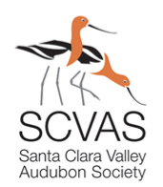
Summer Bird Count
Palo Alto Count Circle: Countdown Event

We’re back in person for the Countdown Dinner this year! All participants in the CBC are invited to join on June 1st to chat over a meal. Please BYOB (alcoholic beverages are OK)—no beverages provided. We’ll review the bird data, share bird stories, and get insider tips on where special birds were seen.
Timeline
5:00 pm: doors open
About 6:00 pm: pizza arrives (bring cash to contribute for pizza)
7:00 pm: Countdown begins
8:30 pm wrap up and go home

Location:
Oddfellows Lodge at 823 Villa Street, downtown Mountain View
Accessible building! Location convenient to Caltrain and VTA!
Free parking available in 1 of the several City parking lots

Please RSVP at: https://bit.ly/SBC_dinner

Questions? Special Dietary Needs?
Contact Ann Hepenstal at pacbc@gmail.com

